**Dependency Inversion Principle**

**Name: Alaa Hamdy Mohammadi**

**Lab: 1**

**Dependency Inversion Definition:**

-High level modules should not depend on low-level modules. Both should depend on abstractions. Abstraction should not depend on details. Details should depend on abstraction.

*High level module: The module or class contain all properties and methods the low-level depends on them.

*Low level module: The module or class handle implementation details depends on high level class.

**Example:**

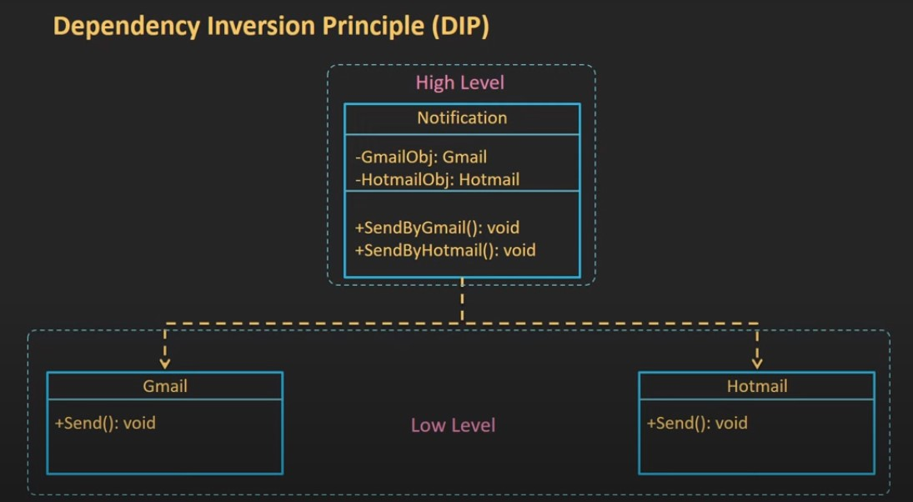

The problem in this example the dependency between modules this called **coupling**. This making changes to one module may require modification in many other modules.

**Solution:**

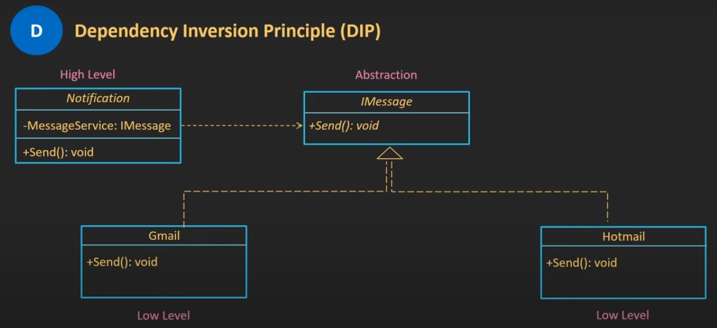

Abstraction allows high-level module to depend on abstract interface rather than connect low-level module. This reduce coupling between modules. High-level module can interact with multiple implementations through the same interface, without knowing the specific details of each implementation.